C Game Programming “Ultra Bullet”

Steven Bojilov

EECE Year 1

14.04.2023

**About:**

The game I made called Ultra Bullet is a spin-off of a website game that has since been discontinued. It isn’t really a game of sorts but a tool to help online chess players move their pieces faster and more precisely in the “Ultra-bullet” mode. I personally liked this program and used it a few times before I found out it no longer existed, so I wanted to recreate it.

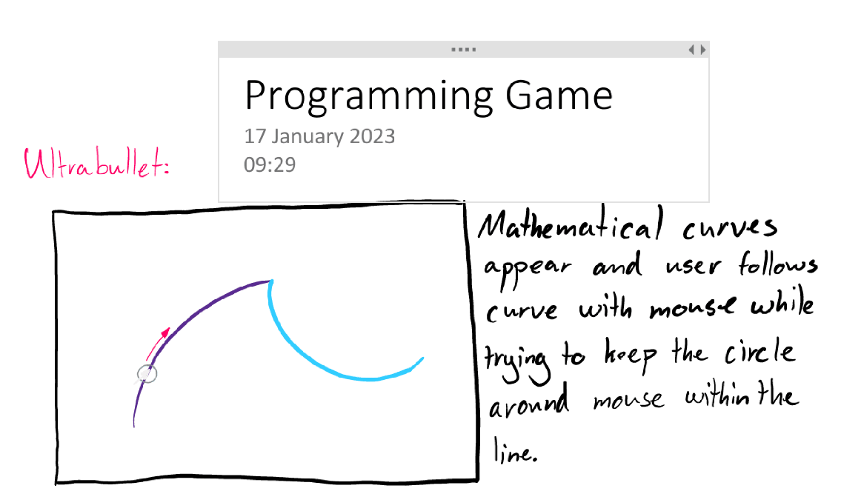

As shown by the diagram, curves appear on the screen and the objective is to trace them with the mouse. That is essentially the entire game, you must keep the line within the circle shown around the mouse.

The curves I used for this program utilizes Cubic Bezier Curves to make smooth variable arcs. This is achieved through the cubic expansion of a value t, which ranges from 0 to 1, and the x/y coordinates of arbitrary points. The formula mathematically is:



*Wikipedia, Bezier Curves*

The curves utilize ‘anchor points’ P0 and P3 and control points P1 and P2 to create the curve which is P as a function of t (in the above formula shown as B(t)).

The program uses SDL 2.0 to render the graphics, I chose this over BGI as it had more functionality and better documentation. (*If you have trouble running the code I can rsvp back with the full Visual Studio Code folder).* SDL 2.0 is very powerful and robust, but lacked functionality for quick 2D vector art which ultimately made it more difficult for this specific application. Though it is still preferred over the BGI header.

The code follows the basic structure of handling events, updating data, and rendering.

The logic in the program remains incomplete as of the writing of this report. The SDL library has collision detection methods designed for textures rather than pixel wide lines. If I were to continue developing, which I likely will as this is a program I personally want to use, I will utilize SDL_Textures to display the Bezier lines and handle collision detection freeing up processing time and making the code more readable and flexible.

The YouTube link for the tutorial on how to play the game:

<https://youtu.be/8OkOMdkKw3k>